2020-2021 Course Recommendation Form

*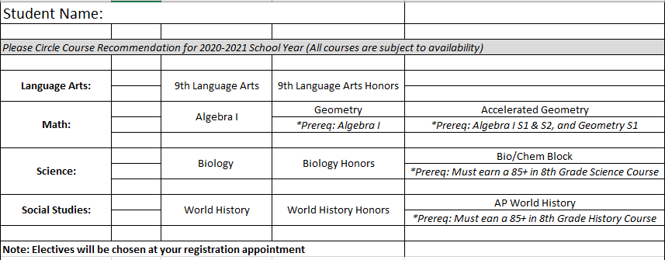To be completed by 8th grade core content teachers*